Art is H.O.T. (Higher-Order Thinking)
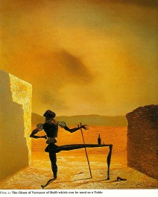
Salvidor Dali, The Ghost of Vermeer of Delft which can be used as a table, 1979
Identify the line, shape and space utilized within the artwork.
(Describe)
Analyze how does the artist use form?
(Analyze)
Interpret the use what you think the image is about.
(Interpretation)
Decide what the artist is communicating through his work of art?
(Interpretation)
Has the artist created an aesthetically pleasing work of art? (Judgement)

Art is H.O.T. (Higher-Order Thinking)
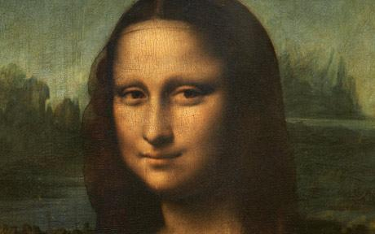
Leonardo Da Vinci, Mona Lisa, 1400”s
Identify the energy of texture, color and value. (Describe)
Analyze how does the artist use light and dark color to create an interesting view point?(Analyze)
Interpret the use of positive and negative space.
(Interpretation)
Decide what the artist is communicating through his work of art?
(Interpretation)
Has the artist’s painted the value of colors and texture realistically in the portrait? Why or why not?
(Judgement)

Art is H.O.T. (Higher-Order Thinking)
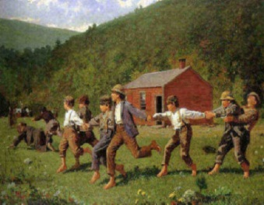
Winslow Homer, Snap the Whip, 1961
Identify how size and shape of the figures create balance within the art., (Describe)
Analyze how does the artist use the lines and color to create movement?
(Analyze)
Interpret the use of elements of art that create rhythm. (Interpretation)
Decide what the artist is communicating through his work of art?
(Interpretation)
Has the artist’s painting demonstrate movement? Why or why not?
(Judgement)

Art is H.O.T. (Higher-Order Thinking)
Henri Matisse, Icarus, 1944
Identify the elements of art and how they relate to Harmony, variety, or unity.
(Describe)
Analyze how does the artist use the color and shapes to create emphasis in movement?
(Analyze)
Interpret the use of space of the artwork.
(Interpretation)
Decide what the artist is communicating through his work of art?
(Interpretation)
Has the emphasized unity with all of the freeform shapes? (Judgement)

Art is H.O.T. (Higher-Order Thinking)
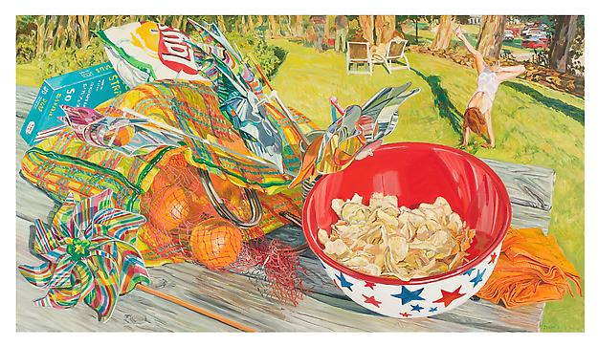
Janet Fish, Cartwheel, 2000
Identify the lines and shapes the artist has used. (Describe)
Analyze how the artist has shown movement in artwork. (Analyze)
Interpret how the artist has created the illusion of space. (Interpretation)
Decide what emotion or feeling the artist is conveying in this artwork. (Interpretation)
Has the artist created an aesthetically pleasing work of art? (Judgement)

Art is H.O.T. (Higher-Order Thinking)
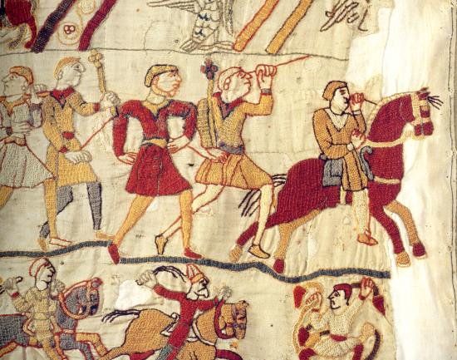
Bayeux Tapestry (detail), 1400s
Identify the colors and textures represented in the artwork. (Describe)
Describe how colors, lines and shapes are arranged to create the image? (Analyze)
Interpret what is happening in the artowrk. (Interpretation)
Interpret what might happen next in this image. (Interpretation)
Decide if you have seen any artworks that are similar to this. (Judgement)
Has the artist created an aesthetically pleasing work of art? (Judgement)

Art is H.O.T. (Higher-Order Thinking)
James Whistler, La Princesse du Pays de la Porcelaine, 1863-65
Identify where you can find pattern in this artwork.
(Describe)
Analyze which part of the artwork shows balance ?
(Analyze)
Interpret why the artist has placed elements in front of and behind the main subject. (Interpretation)
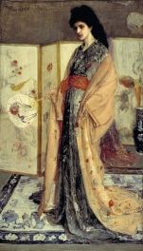
Decide what the artist would like the viewer to take away from the artwork. (Interpretation)
Decide if the artwork is strong enough to hang in an art museum. (Judgement) Has the artist created an aesthetically pleasing work of art? (Judgement)

Art is H.O.T. (Higher-Order Thinking)
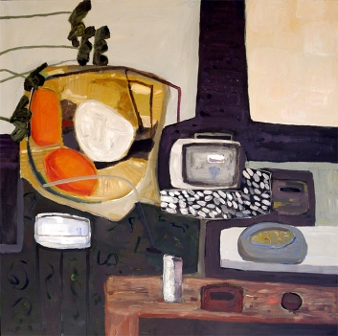
Oliver Bloom, 1961 TV,
Identify what you see in the picture. How would you describe this to someone over the phone? (Describe)
Analyze the colors and shapes that create emphasis?
(Analyze)
Determine what brings harmony and unity to this artwork. (Analyze)
Interpret the mood of the artwork..
(Interpretation)
Decide why the artist has used soft shapes to represent the objects in the painting. (Interpretation)
Decide if you have strong feelings toward the artwork. Would you hang it in your house? (Judgement)

Art is H.O.T. (Higher-Order Thinking)
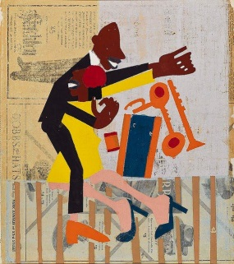
William H. Johnson, Jitterbugs (II), 1941.
Identify the lines and shapes the artist used. (Describe)
Analyze Where did you see do you see diagonal lines? Do you see any curved lines? Where?
Interpret Do the lines in this picture make it active or calm?
Decide Is the picture successful because it is realistic, becaue it is well organized, or because it has a strong message?
Has the artist created an aesthetically pleasing work of art? (Judgement)

Art is H.O.T. (Higher-Order Thinking)
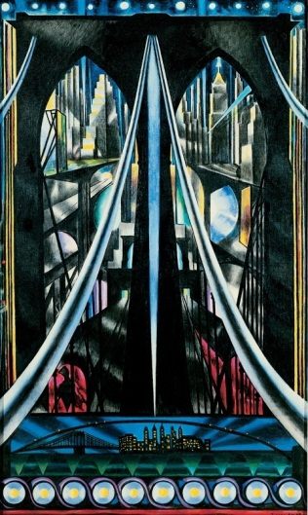
Joseph Stella, Brooklyn Bridge, 1939
Identify the movement of line, shape and space.
(Describe)
Analyze how does the artist use different points of view?
(Analyze)
Interpret the use of elements of art that
(Interpretation)
Decide what the artist is communicating through his work of art?
(Interpretation)
Has the artist created an aesthetically pleasing work of art? (Judgement)

Art is H.O.T. (Higher-Order Thinking)
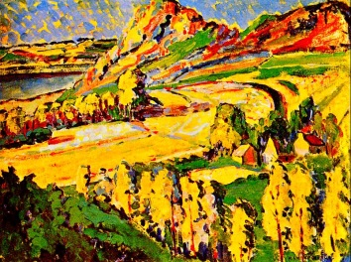
Emily Carr, Autumn in France, 1911
Identify the energy texture, color and value.
(Describe)
Analyze how does the artist use the color to create an interesting view point?
(Analyze)
Interpret the use of elements of art that create perspective. (Interpretation)

Decide what the artist is communicating through his work of art?
(Interpretation)
Has the artist’s title agree with the value of colors and texture? Why or why not?
(Judgement)

Art is H.O.T. (Higher-Order Thinking)
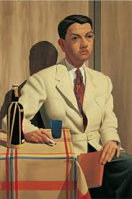
Z. Vanessa Helder, Edmund Giles Tennant, 1939
Identify the energy texture, color and value. (Describe)
Analyze how does the artist use the color to create an interesting view point?
(Analyze)
Interpret the use of elements of art that create perspective.
(Interpretation)
Decide what the artist is communicating through his work of art?
(Interpretation)
Has the artist’s title agree with the value of colors and texture? Why or why not?
(Judgement)

Art is H.O.T. (Higher-Order Thinking)
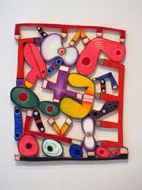
Elizabeth Murray, Path Door, 2002
Identify the elements of art and how they relate to Harmony, variety, or unity.
(Describe)
Analyze how does the artist use the color and shapes to create emphasis?
(Analyze)
Interpret the use of space of the artwork.
(Interpretation)
Decide what the artist is communicating through his work of art?
(Interpretation)
Has the artist’s created a focal point and what are the elements of art that explain your reasoning? (Judgement)

Art is H.O.T. (Higher-Order Thinking)
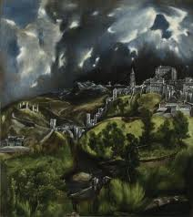
El Greco, View of Toledo, 1596-1600
Identify the different levels of value in the landscape painting. (Describe)
Analyze Where in the painting the artist use texture to create interest? (Analysis)
Interpret which elements of art helped the artist create contrast in the painting. (Interpretation)
Decide what the artist is communicating about the landscape he has painted. (Interpretation)
Has the artist successfully used color and value to create mood? (Judgment)

Art is H.O.T. (Higher-Order Thinking)
Frank Stella, Madinat as-Salam I , 1970
Identify what elements are repeated to create pattern. (Describe)
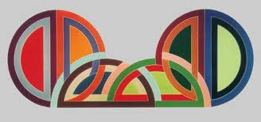
Analyze Where in the painting the artist use repetition to create interest? (Analysis)
Interpret which elements of art helped the artist create a feeling of movement in the painting. (Interpretation)
Decide what type of balance the artist used to structure the visual weight of the composition (Interpretation)
Has the artist successfully used repetition of the elements of art to move the viewer’s eye through the work? (Judgment)

Art is H.O.T. (Higher-Order Thinking)
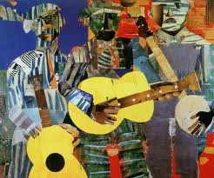
Romare Bearden, Three Folk Musicians, 1967
Identify where repetition creates harmony in the collage. (Describe)
Analyze how the artist uses media to create unity.
(Analyze)
Interpret What is the theme of the piece?
(Interpretation)
Decide what element of art was used to create emphasis. (Interpretation)
Has the artist’s created a focal point, support your observation? (Judgement)

